Accrediting Council
On Education in Journalism and Mass Communications

May 9, 2023
Gayle Hutchinson, President
California State University, Chico
Dear President Hutchinson:
The Accrediting Council on Education in Journalism and Mass Communications met April 28 in Chicago and voted 17-1, with one recusal and one abstention, that the Department of Journalism and Public Relations at California State University, Chico, receive reaccreditation.
The Council concurred with the site team and Committee recommendations for reaccreditation.
Thank you for the opportunity to participate with your faculty and administrators in the assessment of your program. The goal of the Accrediting Council is to improve the quality of education offered to students served by a program through that assessment. Please accept my congratulations and best wishes for success for the Department of Journalism and Public Relations, its students, faculty and the professional media constituencies it serves.
Sincerely,
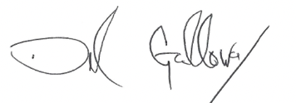
Del Galloway, ACEJMC President
cc
Janell Bauer, Chair
Heidi de Laubenfels, site team chair
Marie Hardin, chair, Accrediting Committee
Patricia Thompson, executive director, ACEJMC

